**Overview of the Indian Air Cargo Market**

**Market Dynamics**

* **Growth Drivers**: E-commerce boom, pharmaceutical exports, perishables, and express logistics.
* **Volume**: India handled over 3.1 million metric tonnes of air cargo in FY2023–24.
* **Key Players**: Blue Dart, SpiceXpress, IndiGo Cargo, Air India Cargo, and international integrators like FedEx and DHL.
* **Infrastructure**: Expansion of cargo terminals at major airports (Delhi, Mumbai, Hyderabad), and development of dedicated air freight corridors.

**IndiGo’s Position and Strategy in Cargo Operations**

**Current Position**

* **Brand**: IndiGo CarGo
* **Fleet**: Converted A321P2F (Passenger-to-Freighter) aircraft; belly cargo on A320/321 fleet.
* **Network**: Over 100 domestic destinations and select international routes.
* **Volume**: IndiGo handled over 100,000 tonnes of cargo in FY2023–24.

**Strategic Focus**

* **Asset-light model**: Using converted aircraft and belly space.
* **Technology-driven**: Real-time tracking, digital booking, and AI-based load optimization.
* **Partnerships**: Collaborations with logistics providers for last-mile delivery.

**Where Does IndiGo Operate Cargo Services?**

**Belly Cargo Operations**

* **Domestic**: Across its 100+ city network in India
* **International**: On select routes to:
  + **Middle East**: Dubai, Doha, Abu Dhabi
  + **Southeast Asia**: Singapore, Bangkok, Colombo
  + **South Asia**: Kathmandu, Dhaka

**Dedicated Freighter Operations**

* **Aircraft**: A321P2F (converted freighters)
* **Hubs**: Delhi, Mumbai, Hyderabad
* **Routes**: Primarily domestic, with plans to expand to international corridors like Dubai and Singapore

**Pros and Cons of Belly Cargo for IndiGo**

**Pros**

* **Cost-effective**: Utilizes existing passenger flights
* **High frequency**: Leverages IndiGo’s dense domestic network
* **Quick to scale**: No need for separate aircraft or crew

**Cons**

* **Limited capacity**: Especially on high-load passenger flights
* **Restricted cargo types**: No hazardous or oversized goods
* **Dependent on passenger schedules**: Less flexibility for logistics clients

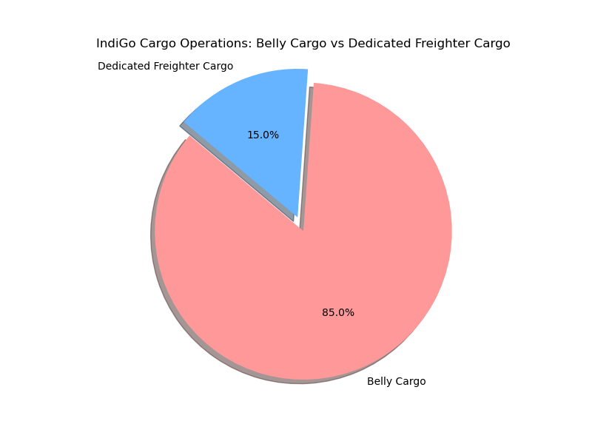

**Current Split (2024–25 Estimate)**

* **Belly Cargo**: 85%
* **Dedicated Freighter Cargo**: 15%

**Prospects**

* IndiGo’s **dedicated freighter share is projected to double** to **30%** over the next 5 years.
* This growth will be driven by:
  + Expansion of the A321P2F freighter fleet
  + Entry into international cargo corridors
  + Strategic partnerships with logistics and e-commerce firms
  + Increasing demand for time-sensitive and high-volume cargo services

**Porter’s Diamond Model: Factors Affecting National Competitiveness**

**1. Factor Endowments**

* **Strengths**:
  + Skilled labor in logistics and aviation.
  + Strategic location between Europe and Southeast Asia.
  + Growing airport infrastructure (e.g., GMR Hyderabad Cargo Terminal).
* **Weaknesses**:
  + Limited domestic aircraft manufacturing.
  + Inconsistent cold-chain infrastructure.

**2. Demand Conditions**

* **Rising demand** from:
  + E-commerce (Amazon, Flipkart)
  + Pharmaceuticals (India is a global pharma hub)
  + Perishables (fruits, seafood)
* **Customer expectations**: Fast, reliable, and trackable services.

**3. Related and Supporting Industries**

* **Logistics ecosystem**: Rapid growth in warehousing, 3PLs, and digital freight platforms.
* **Support gaps**: Limited MRO (Maintenance, Repair, Overhaul) for freighters.

**4. Firm Strategy, Structure, and Rivalry**

* **Competitive landscape**: Blue Dart (integrated express), SpiceXpress (dedicated freighters), and global players.
* **IndiGo’s strategy**:
  + Cost leadership through operational efficiency.
  + Expansion into underserved cargo corridors.
  + Digital-first approach to cargo booking and tracking.

**Motivations for IndiGo’s Cargo Expansion**

1. **Revenue Diversification**: Cargo offers counter-cyclicality to passenger demand.
2. **E-commerce Growth**: India’s e-commerce market is expected to reach $200B by 2026.
3. **Asset Utilization**: Belly cargo monetizes existing passenger flights.
4. **Global Trade Integration**: India’s exports (e.g., electronics, textiles) need reliable air freight.

**Risks in Cargo Expansion**

|  |  |
| --- | --- |
| Risk Type | Description |
| Operational | Managing cargo and passenger services simultaneously |
| Regulatory | Customs delays, international compliance |
| Competitive | Pressure from integrated players like Blue Dart and FedEx |
| Infrastructure | Inadequate cold-chain and warehousing at Tier-2 airports |
| Economic Cycles | Trade slowdowns or fuel price volatility affecting margins |

**Entry Modes and Progress**

**Entry Modes Used**

* **Organic Expansion**: Using belly space on passenger aircraft.
* **Fleet Conversion**: A321P2F freighters for dedicated cargo operations.
* **Strategic Partnerships**: With logistics firms for ground handling and last-mile delivery.

**Progress So Far**

* **Fleet**: 3+ A321P2F aircraft in operation (as of 2024).
* **Network**: Domestic cargo hubs in Delhi, Mumbai, Hyderabad; international expansion underway.
* **Digitalization**: Cargo booking portal, real-time tracking, and AI-based load planning.

**Key Insights:**

1. **Revenue (INR Cr)**
   * **Passenger**: ₹35,000 Cr
   * **Cargo**: ₹1,200 Cr
   * While cargo contributes a small portion, it represents a growing revenue stream.
2. **Growth Rate (%)**
   * **Cargo**: 25%
   * **Passenger**: 10%
   * Cargo is growing at a significantly faster pace, driven by e-commerce and logistics demand.
3. **Operating Margin (%)**
   * **Cargo**: 15%
   * **Passenger**: 8%
   * Cargo operations are more profitable per unit, likely due to lower service costs and higher yield per kg.
4. **Contribution to Total Revenue (%)**
   * **Passenger**: 97%
   * **Cargo**: 3%
   * Despite its small share, cargo is strategically important for diversification and margin enhancement.

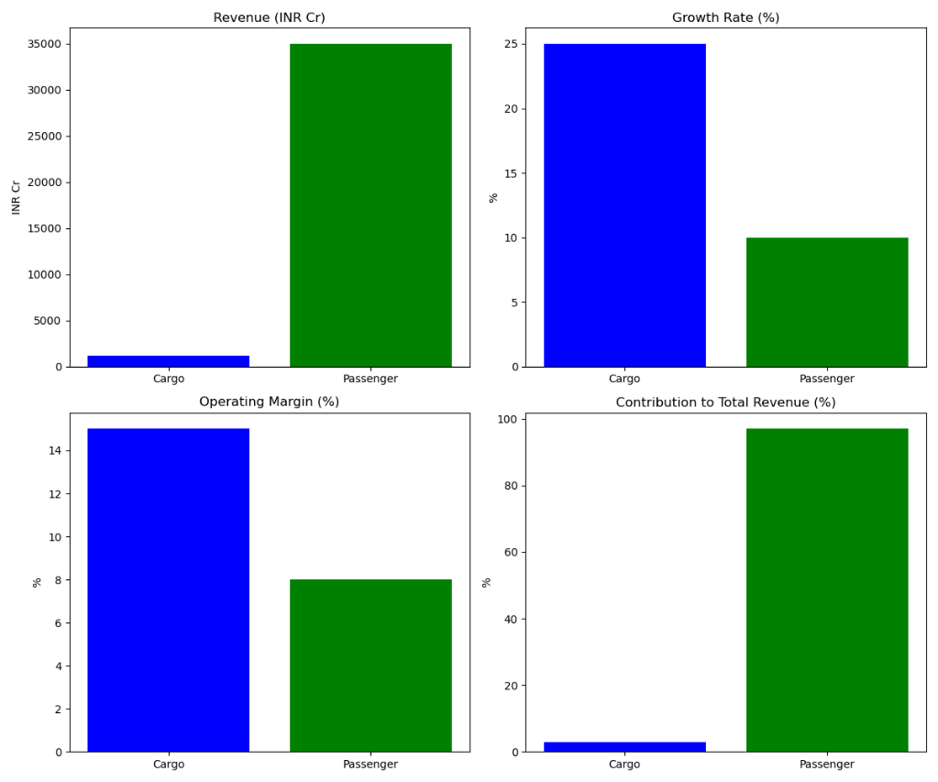

**Comparative analysis of IndiGo Cargo versus its key rivals in the Indian air cargo market:**

**Key Metrics Comparison**

|  |  |  |  |  |
| --- | --- | --- | --- | --- |
| Metric | IndiGo Cargo | Blue Dart | SpiceXpress | Air India Cargo |
| Market Share (%) | 15% | 40% | 25% | 20% |
| Annual Revenue (INR Cr) | ₹1,200 Cr | ₹3,000 Cr | ₹1,800 Cr | ₹1,500 Cr |
| Cargo Volume (000 tonnes) | 100 | 250 | 150 | 120 |

**Competitive Insights**

* Blue Dart leads the market with a 40% share, driven by its integrated express logistics model and dedicated freighter fleet.
* SpiceXpress has a strong presence in Tier-2/3 cities and operates Boeing 737 freighters.
* Air India Cargo benefits from its wide-body international network and belly cargo capacity.
* IndiGo Cargo, while smaller in scale, is growing rapidly with a 25% YoY growth rate and higher operating margins due to efficient fleet utilization and digital operations.

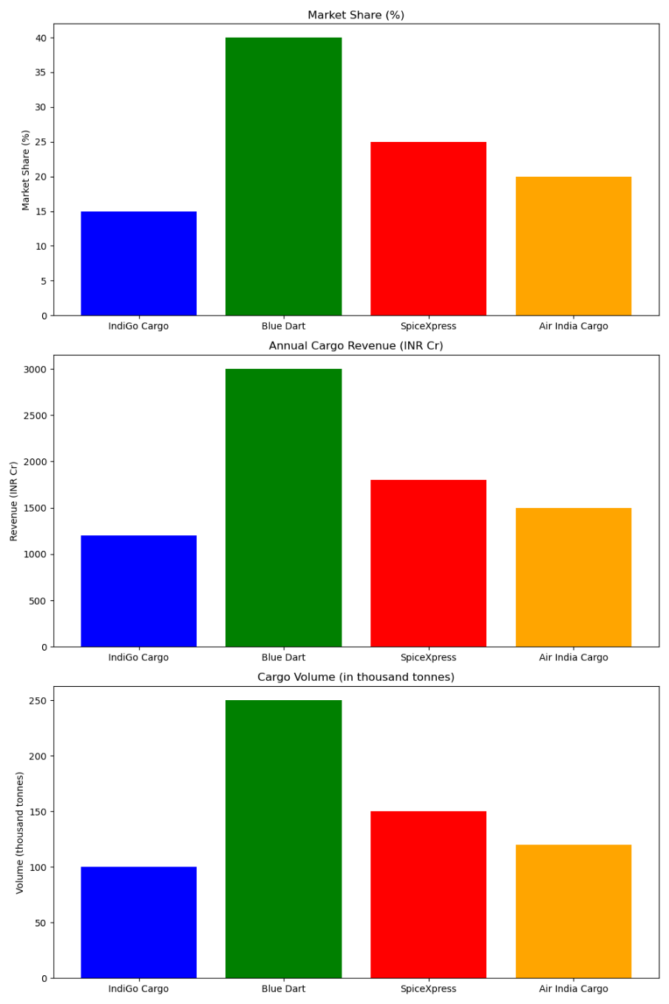

Future Strategy Recommendations for IndiGo Cargo

1. Expand Dedicated Freighter Fleet

* Why: To serve high-volume and time-sensitive cargo markets independently of passenger schedules.
* How:
  + Convert older A320s to freighters (P2F conversions).
  + Lease or acquire A330 or Boeing 767 freighters for medium- to long-haul routes.
* Example: SpiceXpress uses Boeing 737 and 767 freighters to serve regional and international markets.

2. Develop International Cargo Corridors

* Why: To tap into high-yield trade lanes and support India’s export economy.
* How:
  + Launch dedicated cargo flights to Dubai, Singapore, Frankfurt, and Nairobi.
  + Use belly cargo on international passenger routes as a steppingstone.
* Example: Emirates SkyCargo’s India–Europe corridor success can be a model.

3. Form Strategic Global Partnerships

* Why: To extend reach and integrate into global supply chains.
* How:
  + Partner with international logistics firms (e.g., DHL, DB Schenker).
  + Codeshare or interline agreements with foreign cargo carriers.
* Example: Qatar Airways Cargo’s partnerships with regional carriers for last-mile delivery.

4. Invest in Cold Chain and Pharma Logistics

* Why: India is a global pharmaceutical hub; cold chain is a high-margin segment.
* How:
  + Build temperature-controlled facilities at key hubs (Delhi, Hyderabad).
  + Offer GDP-compliant pharma logistics solutions.
* Example: Hyderabad Pharma City collaboration for pharma exports.

5. Leverage Technology and AI

* Why: To improve efficiency, reduce costs, and enhance customer experience.
* How:
  + Implement AI for demand forecasting and dynamic pricing.
  + Use IoT for real-time cargo tracking and predictive maintenance.
* Example: Lufthansa Cargo uses AI for load optimization and route planning.

6. Sustainability and ESG Integration

* Why: Align with global environmental standards and customer expectations.
* How:
  + Use Sustainable Aviation Fuel (SAF) for freighter operations.
  + Offer carbon-neutral shipping options to clients.
* Example: KLM Cargo’s SAF-powered freight flights.

International Expansion Strategy

|  |  |  |
| --- | --- | --- |
| **Phase** | **Focus Area** | **Key Actions** |
| **Phase 1** | Regional Expansion | Use belly cargo on flights to Gulf, Southeast Asia |
| **Phase 2** | Dedicated Freighter Launch | Start freighter ops to Dubai, Singapore, Frankfurt |
| **Phase 3** | Strategic Alliances | Partner with global integrators and regional carriers |
| **Phase 4** | Infrastructure Investment | Build cargo hubs and cold chain facilities |
| **Phase 5** | Digital & ESG Leadership | Launch AI-driven cargo platform and green logistics |

**Directorate General of Civil Aviation (DGCA), India** –

<https://dgca.gov.in>

**Airports Authority of India (AAI)** –

<https://aai.aero>

**IndiGo (InterGlobe Aviation Ltd.) Investor Relations** –

<https://www.goindigo.in/about-us/investor-relations.html>

**Blue Dart Express Ltd.** –

<https://www.bluedart.com>

**SpiceJet (SpiceXpress)** –

<https://www.spicexpress.com>

**CAPA India** –

<https://www.capaindia.com>

**IATA (International Air Transport Association)** –

<https://www.iata.org>

<https://www.moneycontrol.com>

<https://www.business-standard.com>

<https://www.livemint.com>